
IT2010 – Mobile Application Development
BSc (Hons) in Information Technology
2nd Year
Faculty of Computing
SLIIT
2025 – Lab Exam 02

Report



Description:

R Shoes Online is an innovative mobile application designed to be the ultimate footwear shopping experience, offering a seamless and convenient way for users to discover and purchase the latest shoe trends. By browsing categories or searching for specific brands, customers can access a curated selection of stylish sneakers, formal shoes, athletic footwear, and more, ensuring they find the perfect pair for any occasion.
The app features real-time inventory updates, allowing users to see product availability and make informed purchase decisions. With an intuitive interface, shoppers can easily filter by size, color, brand, and price, enhancing their browsing experience.
To provide a hassle-free shopping journey, R Shoes Online integrates secure payment methods and fast, reliable shipping options. Whether selecting standard delivery, express shipping, or in-store pickup, users can choose the most convenient method for receiving their orders. Additionally, the app includes a smart recommendation system that suggests shoes based on past purchases and preferences.
Multi-language support ensures accessibility for a diverse global audience, while push notifications keep users updated on new arrivals, exclusive discounts, and order tracking. By combining a userfriendly shopping experience, real-time updates, and seamless transactions, R Shoes Online redefines online footwear shopping, making it effortless, enjoyable, and stress-free.

Screenshots:



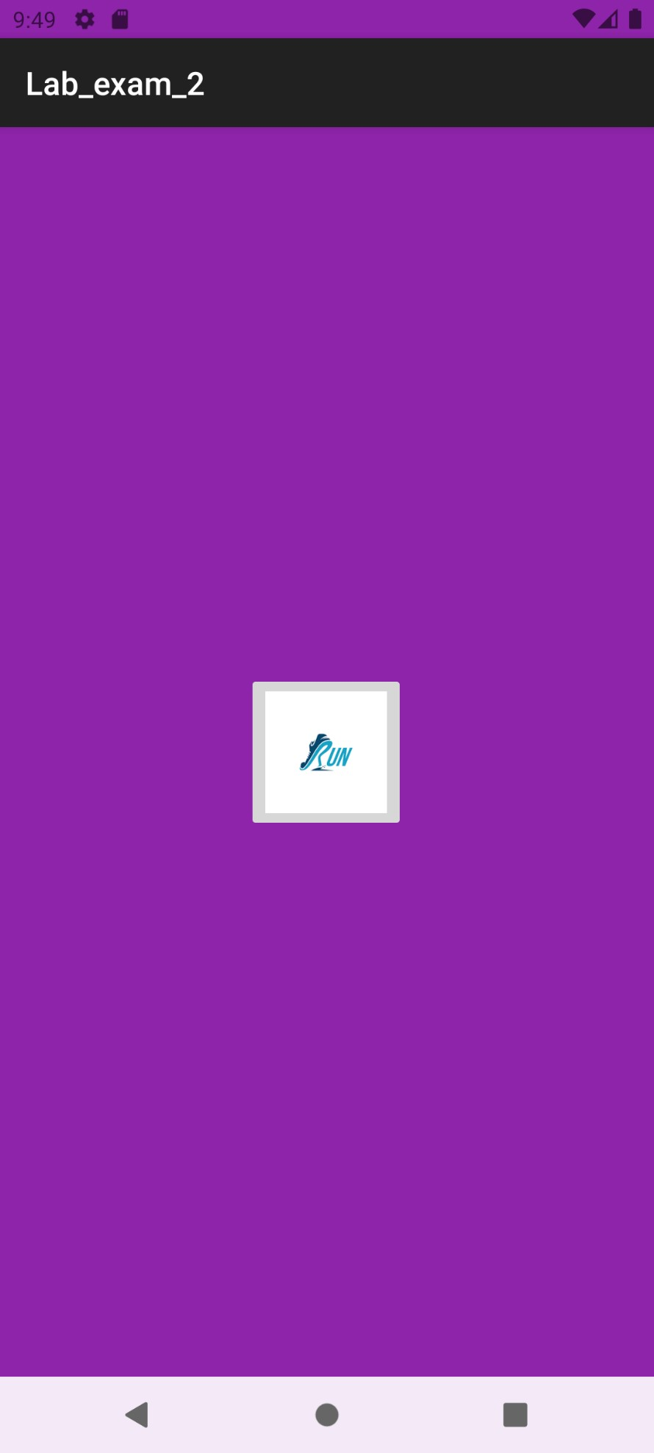
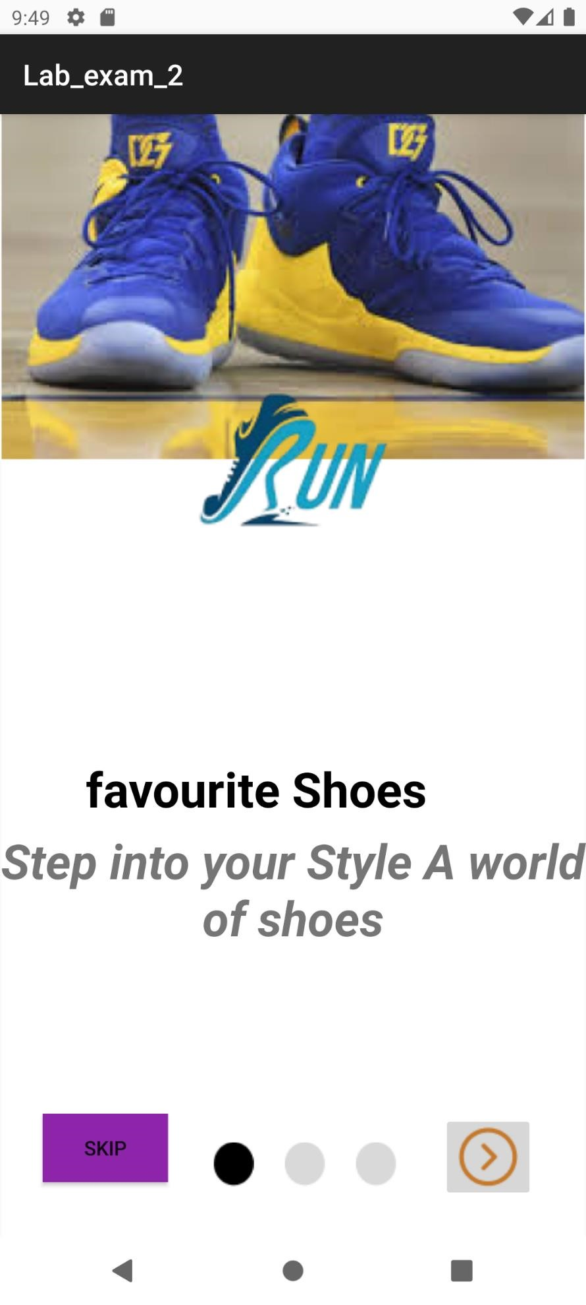



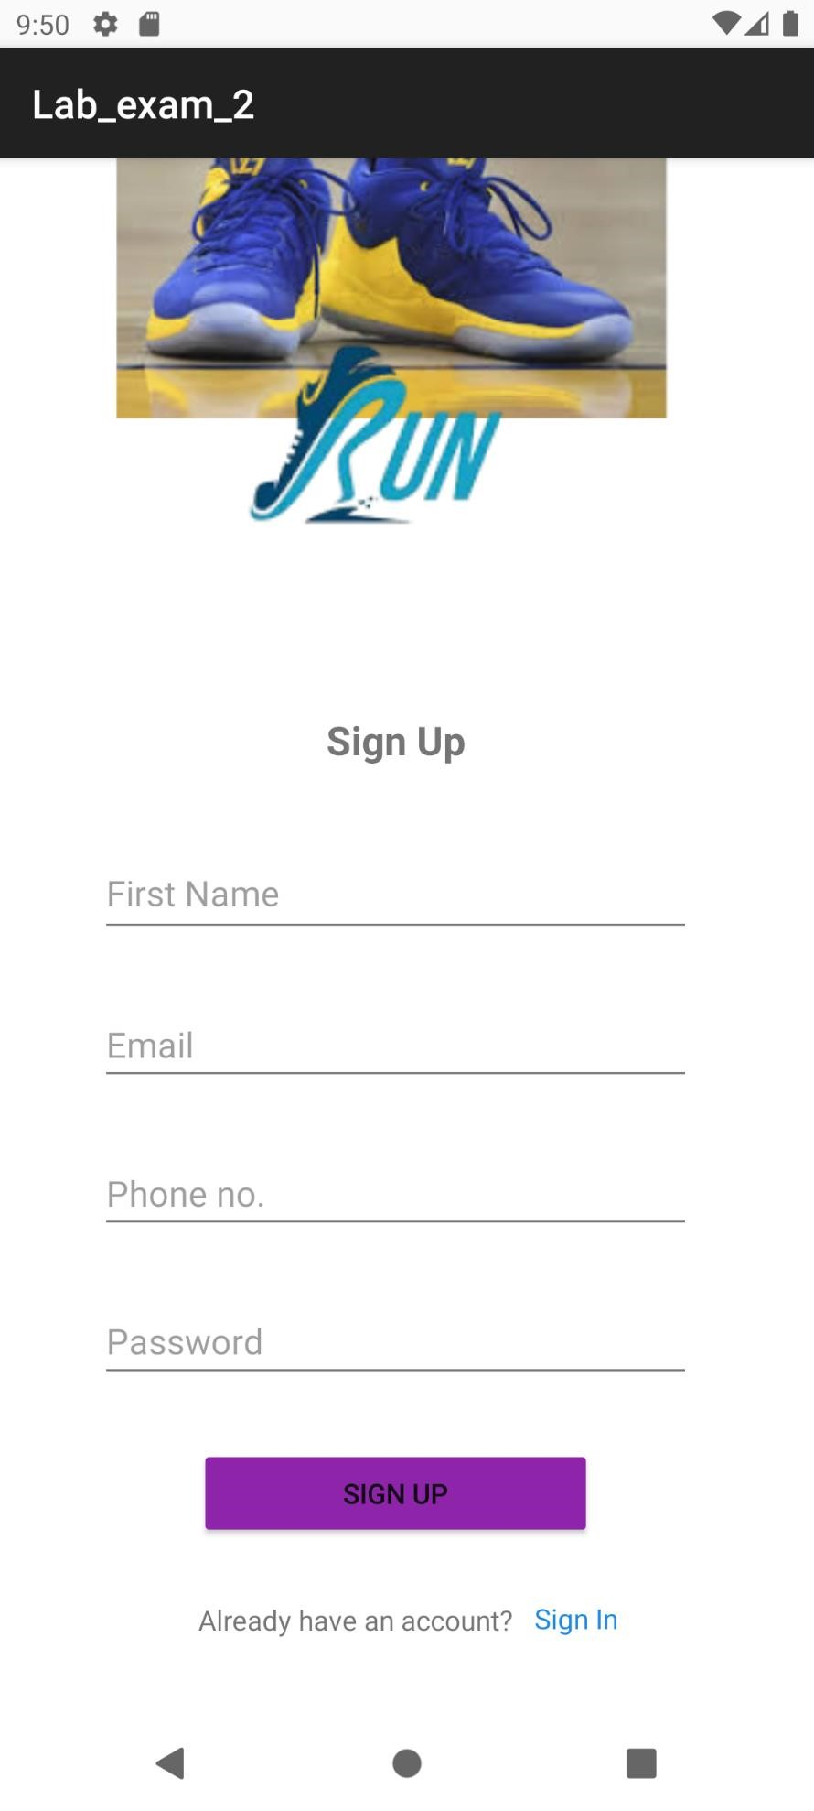
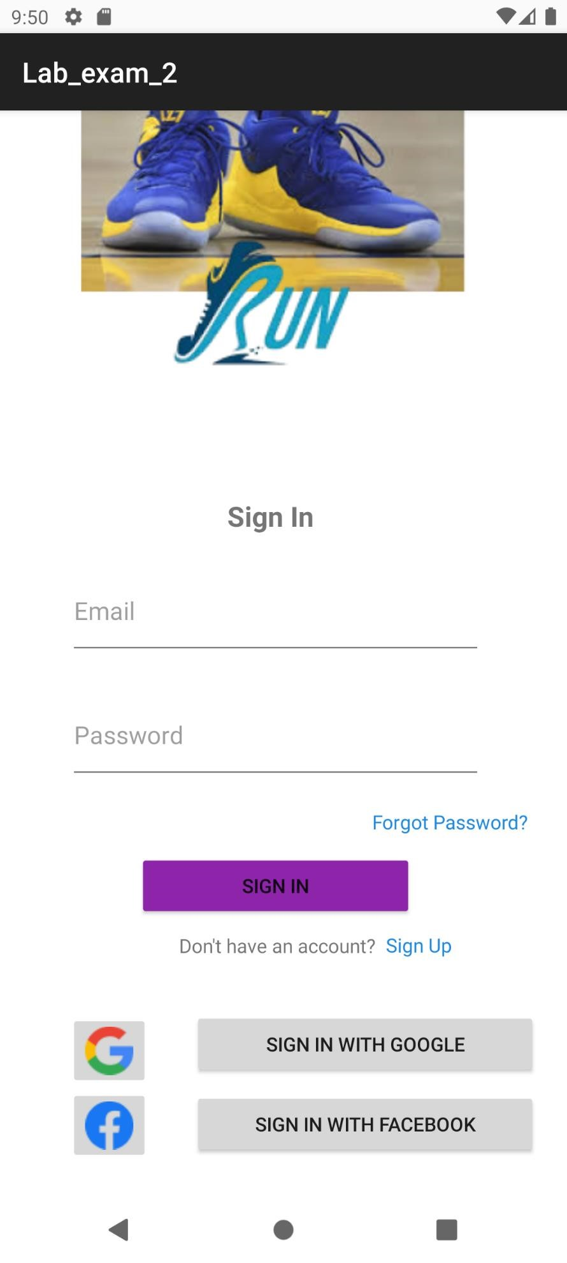
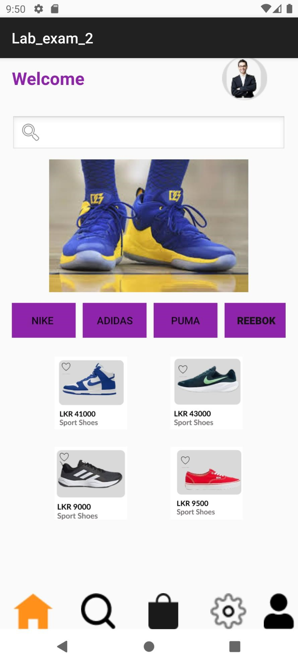
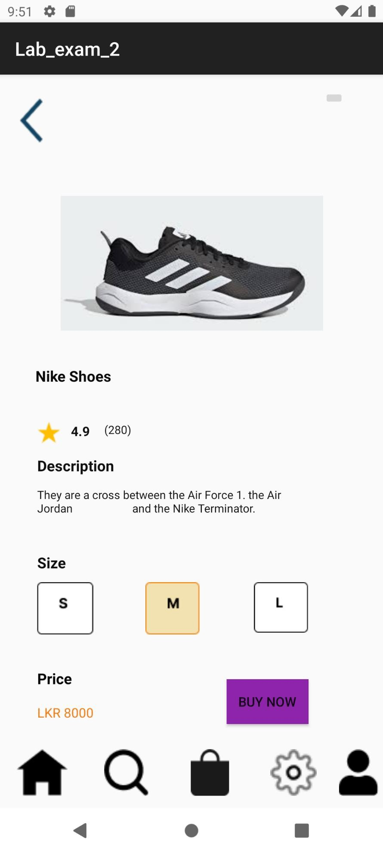
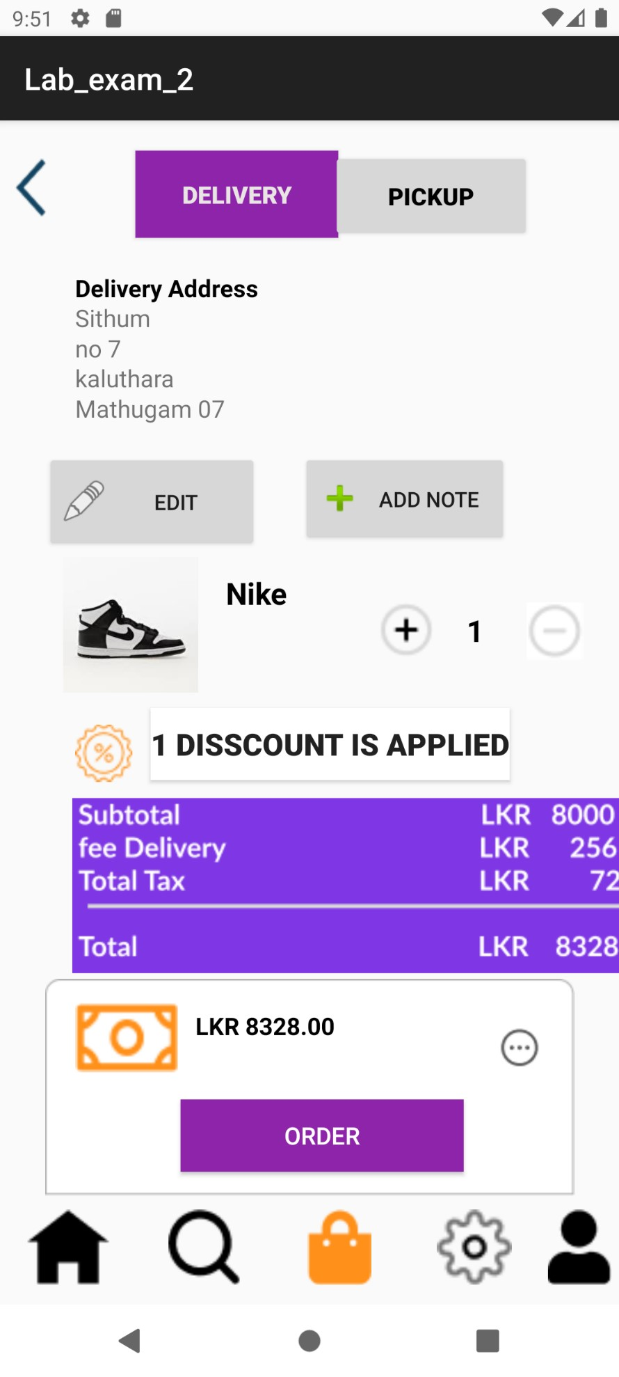
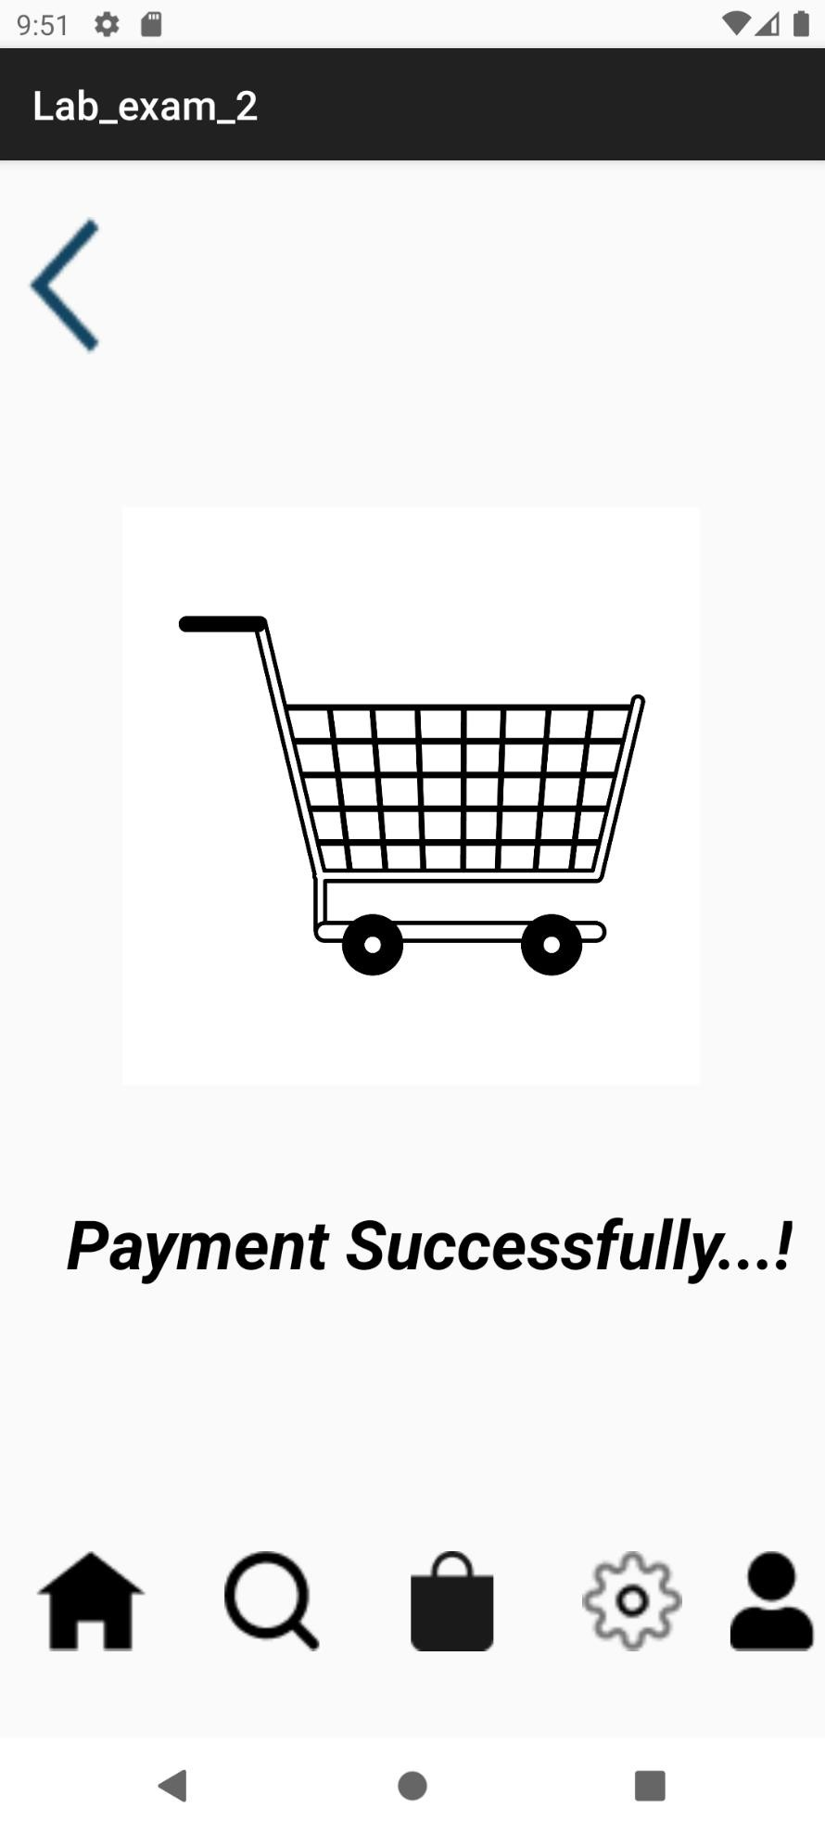
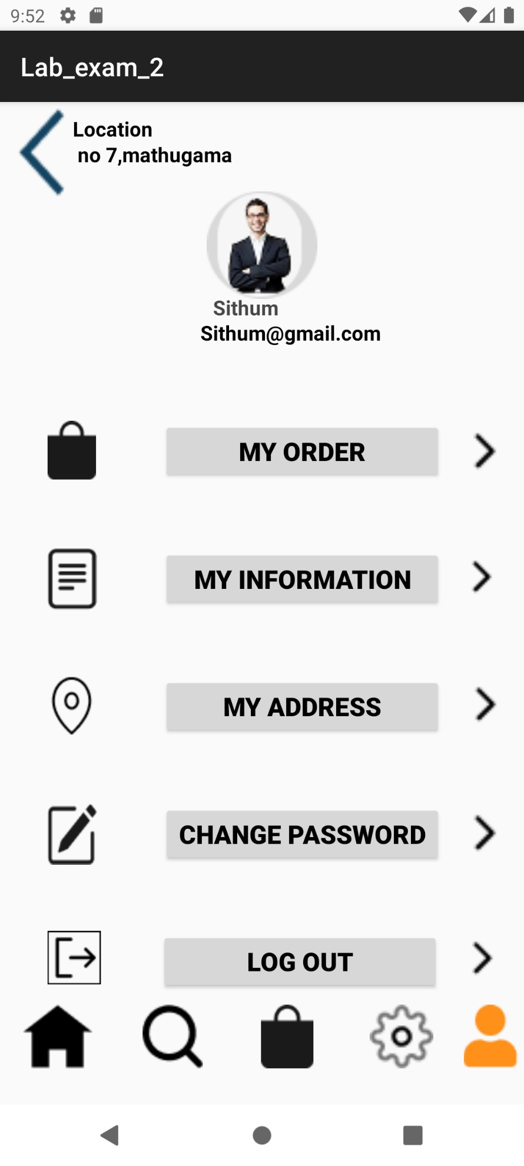
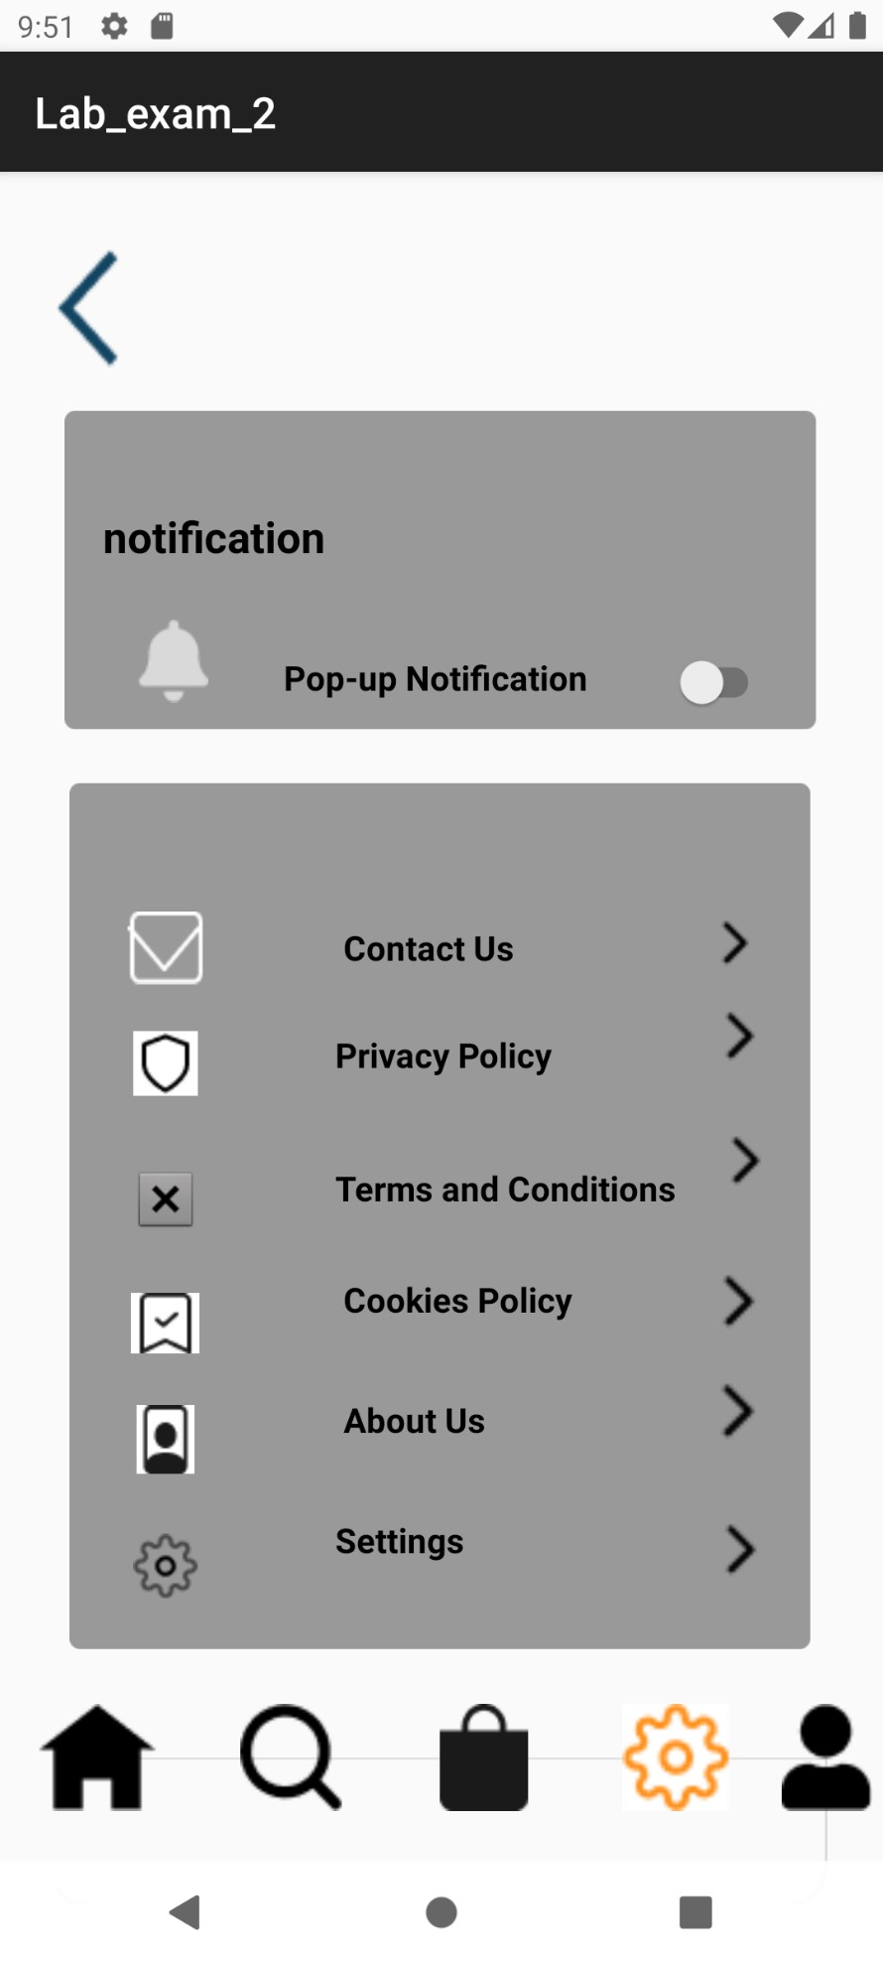
Content of xml files of Strings and Colors: Strings
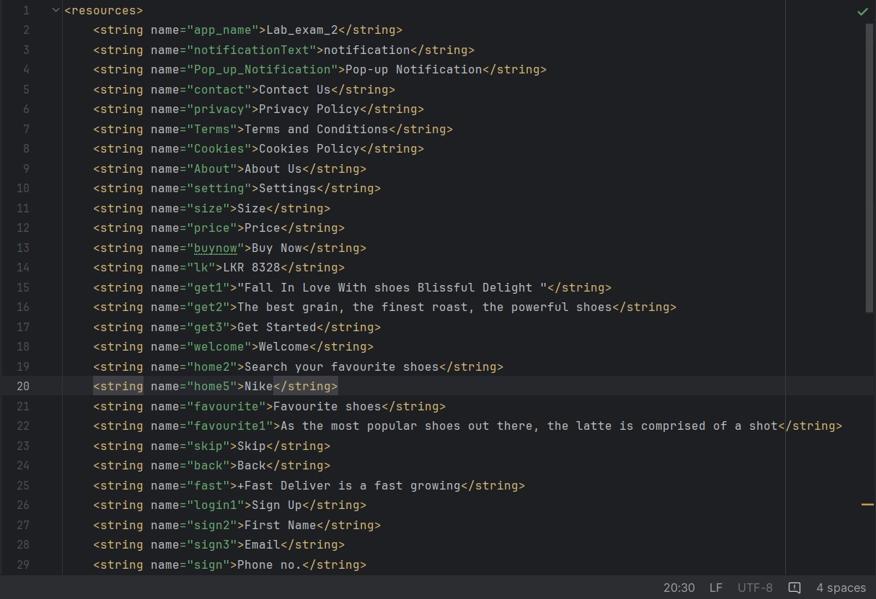
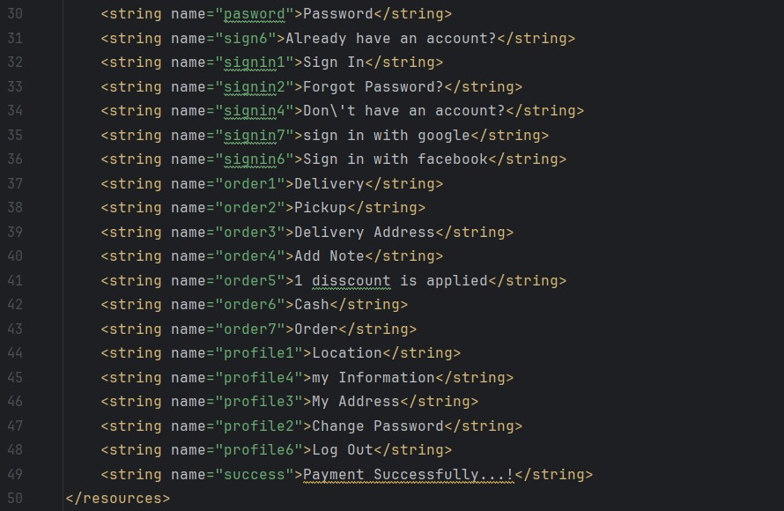

Colors
